Graphing M365: Lab One

# Objective

In this lab, students shall install Neo4j as the graph database for later lessons. All lessons are OS agnostic, however, Microsoft Windows will have the best out of the box experience for attendees.

# Directions

## Installing Neo4j

1. Open a browser and navigate to [Get Neo4j Desktop - Neo4j Graph Data Platform](https://neo4j.com/download/neo4j-desktop/?edition=desktop)
2. Complete the form and download the tool.

1. If the download doesn’t start, select from the links near the top of the page.

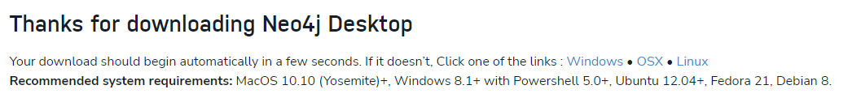

1. When the file Neo4j installer completes downloading, open the installer.  
   
2. Using the default installation values, go through the installation.
3. When the installation completes, open the Neo4j application.
4. On the first run, it will ask where you want to store application data, the default option is acceptable. Select **Confirm** to continue.  
   Graphical user interface, text, application

   Description automatically generated
5. On the next page, copy the key from the Neo4j website download page and paste it into the **Software Key** box on the desktop application.

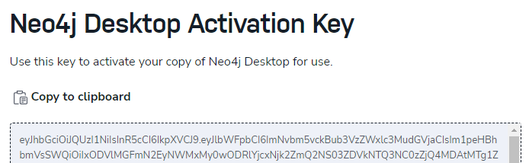

1. After the setup completes, you may be prompted to update Graph apps. Go ahead and update them all.

## Configuring PowerShell

1. Open an administrative PowerShell prompt
2. Run the following command  
   Install-Module -Name Microsoft.Graph
3. Accept any prompts provided by PowerShell to complete installation.